Supplemental Figures for “Temporal dynamics of auditory bistable perception correlated with a fluctuation of baseline pupil size”

Yuta Suzuki, Hsin-I Liao, Shigeto Furukawa

25 January, 2022

*Corresponding author: Yuta Suzuki NTT Communication Science Laboratories, NTT Corporation, Atsugi 243-0198, Japan Tel: +81-046-240-3525, E-mail: [yuuta.suzuki.fc@hco.ntt.co.jp](mailto:yuuta.suzuki.fc@hco.ntt.co.jp)

## Estimated mm results for Figure 2A and 3A

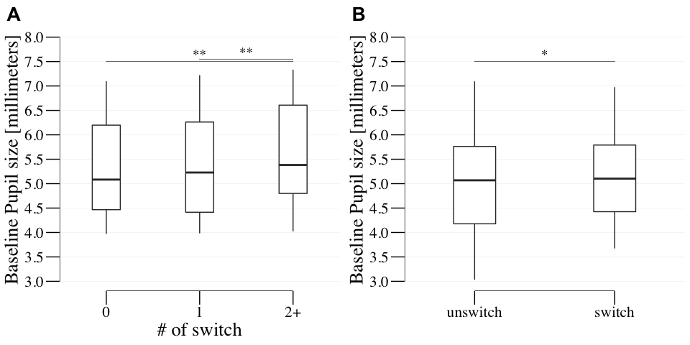

## quartz_off_screen   
## 2

We illustrated the baseline pupil size using millimeters converted from pixels with the same analysis as **Figure 2A** and **3A** in the main manuscript. **Supplementary Figure 1A** shows the grand-averaged baseline pupil changes across participants before the response cue onset, as a function of perceptual alternations number. The one-way repeated measures ANOVA revealed a significant main effect on the number of perceptual alternations ((1.67,35.02) = 9.489, = 0.001, = 0.311, = 67.669). The post-hoc multiple comparisons showed that the baseline pupil size in the >1-alt case was significantly larger than in the 0- and 1-alt cases ((21) = 3.57, = 0.002, Cohen’s = 0.761, = 21.411; (21) = 3.175, = 0.005, Cohen’s = 0.677, = 9.661, respectively), **Supplementary Figure 1B** shows the grand-averaged time-course of baseline pupil changes parameterized by alternation cases (yes or no). A paired t-test for averaged changes in baseline pupil size from -1000 ms to the response cue onset for each answer (i.e., the presence or absence of perceptual alternation) showed that the baseline pupil size in the presence of a perceptual alternation was significantly larger than in the absence of perceptual ((18) = -2.312, = 0.033, Cohen’s = 0.53, = 1.974).

## Transient Pupil Dilation/Constriction (PD/PC)

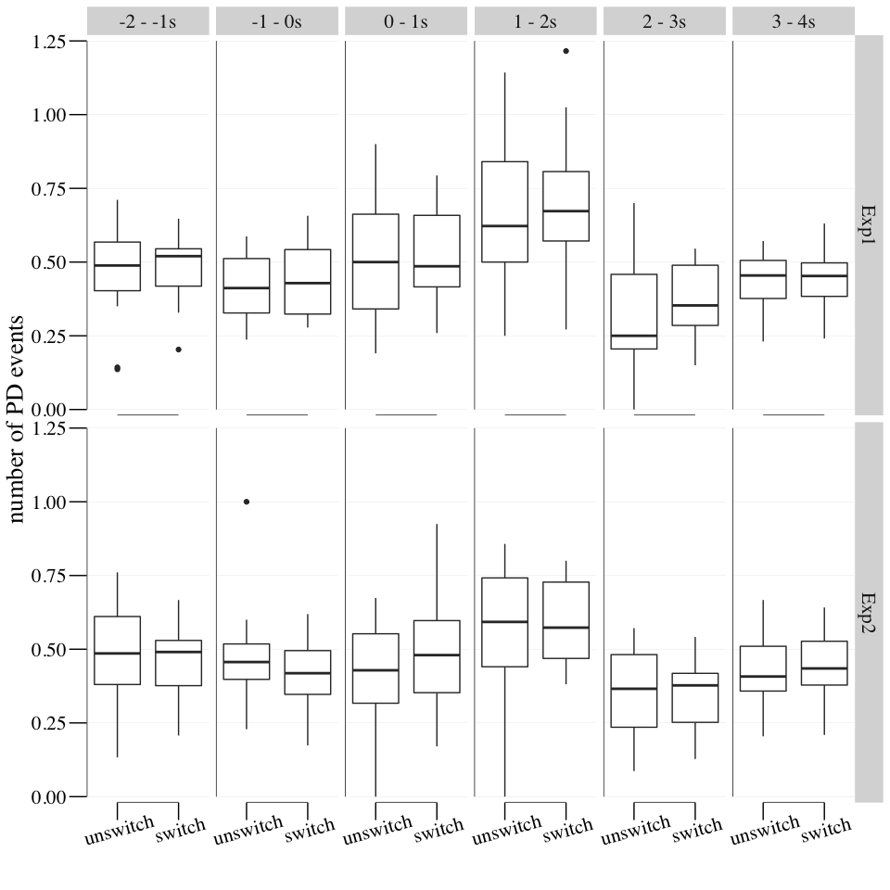

## quartz_off_screen   
## 2

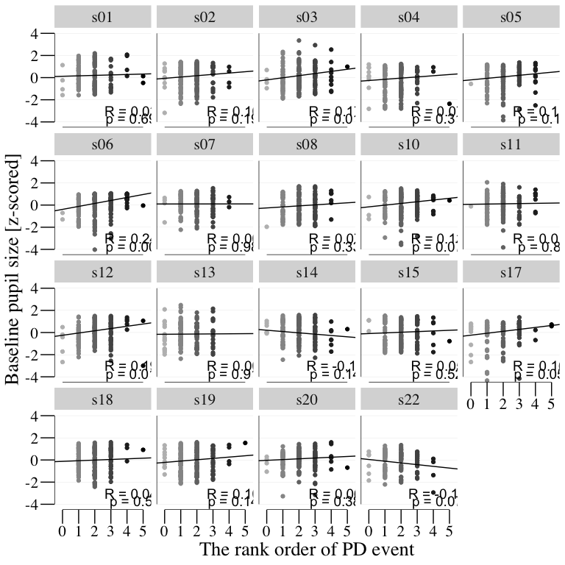

## quartz_off_screen   
## 2

There was a concern that the PD events and observed baseline pupil size were not sufficiently independent measures. For example, if the transient pupil dilation had a sufficiently slow time decay, the apparent baseline diameter would build up with accumulated PD events. To address this concern that the baseline pupil size might be affected by the PD events, we calculated the number of PD events in the baseline pupil size analysis in every 1-s time bin **(Supplementary Fig. 2)** and the correlation between the baseline pupil size and number of transient PD events **(Supplementary Fig. 3)**.

The three-way repeated measures ANOVA (the presence of alternation x time bins x experiments), however, only revealed a significant main effect of time bins ((2.71,48.81) = 12.383, = 0, = 0.408, = 2.6285657^{7}). The post-hoc multiple comparisons showed that the number of PD events in time bin of 1 to 2s were larger than −2 to −1s, −1 to 0s, 2 to 3s, 3 to 4s (adj.p < 0.05). This could be explained by motor responses such as button-press responses **(Einhäuser et al., 2010; Grenzebach et al., 2021; Hupé et al., 2009)**. Other main factors and interactions were not significant (p > 0.05).

We further calculated the correlation between the baseline pupil size and the number of transient PD events as shown in **Supplementary Fig.3**. The number of PD events during the early 4-s part of the observation period (see **Figure 1**) were summed and their order ranked across trials for each subject. The baseline pupil size after the window for calculating the number of PD events was parameterized by the rank order of the PD events. The data were fitted by a simple regression model in each subject. The correlation coefficient and p-value of the correlation are described in each panel. Although three participants out of 19 had a significant positive correlation, it turns out that there seems to be no strong statistical evidence that increasing the number of PDs can explain the baseline pupil size in both experiments. From these analyses, we conclude that our results cannot be attributed to concerns that the baseline pupil size might be affected by the PD events.